Task 4 – Evidence Report
Multi-Node Kubernetes Cluster Build (Kind) & Reproducibility via GitHub
Student | Kabir Singh Thukrai
Course | DSYS601 – DevOps / BCIS309 Industry Project
Task | Task 4 – Multi-node cluster build, reproducible from scripts/manifests (1 control-plane, 2 worker nodes)
Tool used | Kind (Kubernetes IN Docker) on Ubuntu 22.04 LTS (VMware VM)
Repository | https://github.com/kat0870/dsys601-k8s-observability-lab

1. Objective
Build a reproducible, multi-node Kubernetes lab cluster (1 control-plane node, 2 worker nodes) using Kind, verify it is operational, and store the cluster configuration and setup/teardown scripts in a version-controlled GitHub repository so the environment can be rebuilt reliably between cohorts.

2. Environment & Tooling Verification
Before building the cluster, Docker, Kind and kubectl were confirmed installed and working on the Ubuntu 22.04 LTS VM:
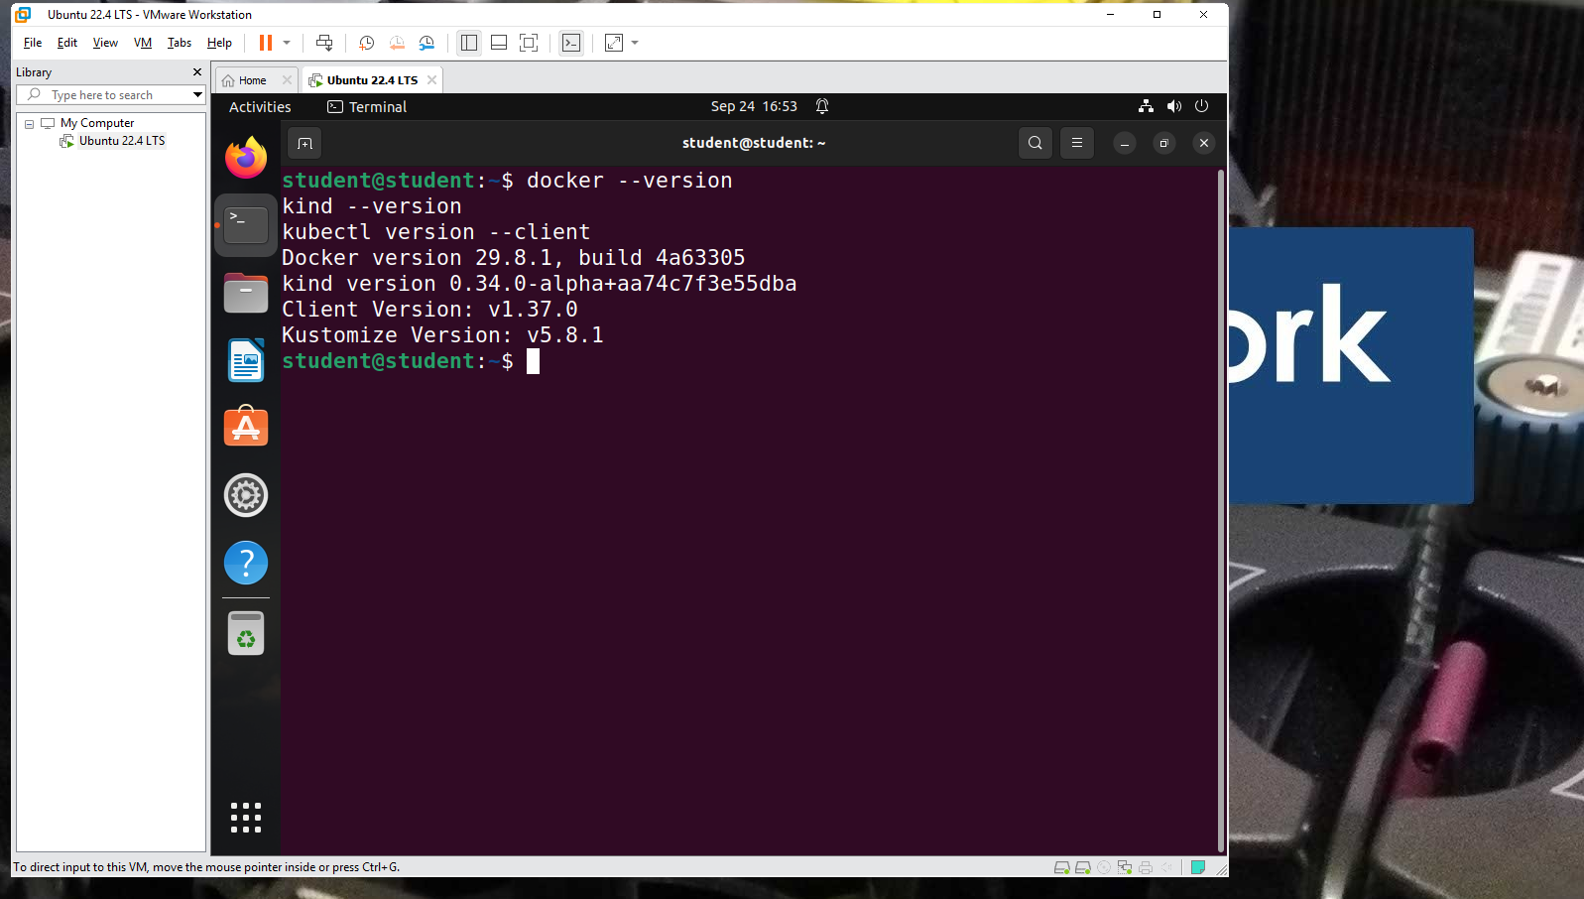
Figure 1 – Docker, Kind and kubectl version check
docker --version
kind --version
kubectl version --client

3. Cluster Configuration File
A Kind configuration file was written to define one control-plane node and two worker nodes:
kind: Cluster
apiVersion: kind.x-k8s.io/v1alpha4
nodes:
- role: control-plane
- role: worker
- role: worker

4. Troubleshooting the Cluster Build
The first attempts to create the cluster failed while joining the worker nodes, with kubelet reporting a cgroups misconfiguration. The issue was diagnosed and resolved step by step, as documented below.
4.1 Initial failure – worker nodes could not join
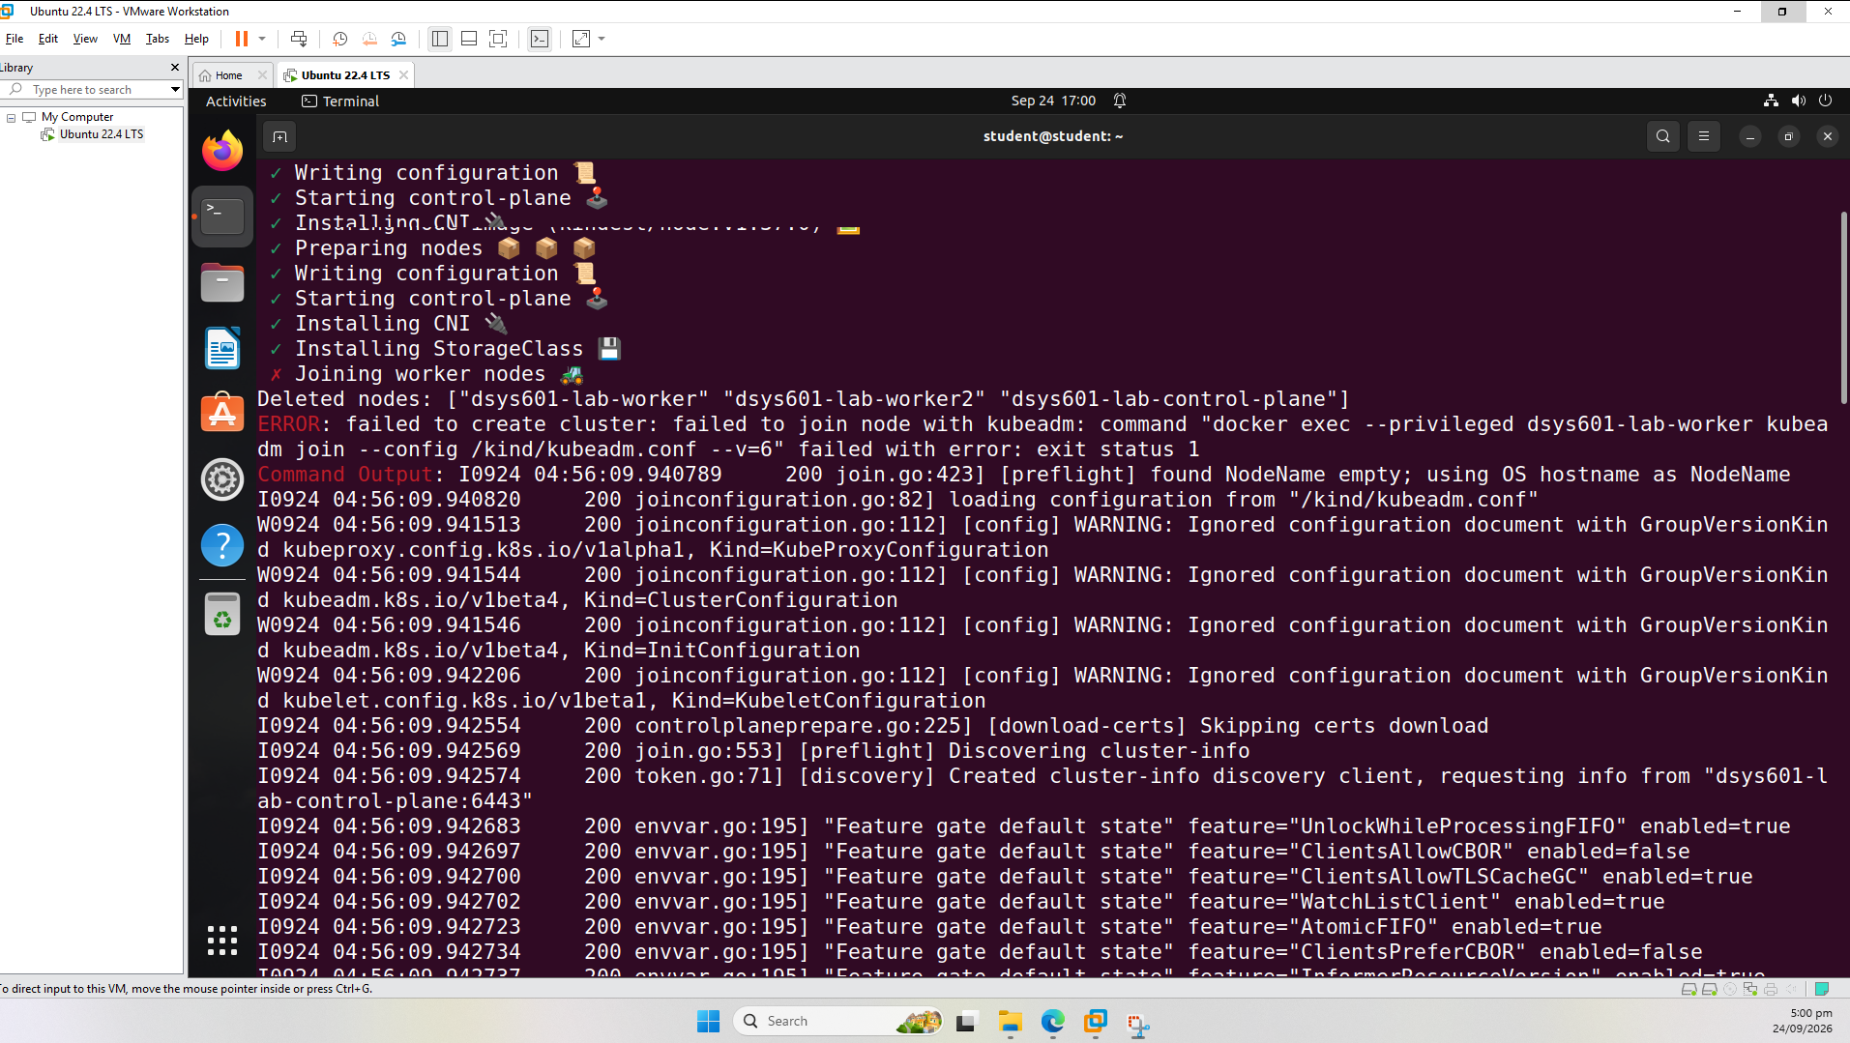
Figure 2 – kind create cluster failing at 'Joining worker nodes'
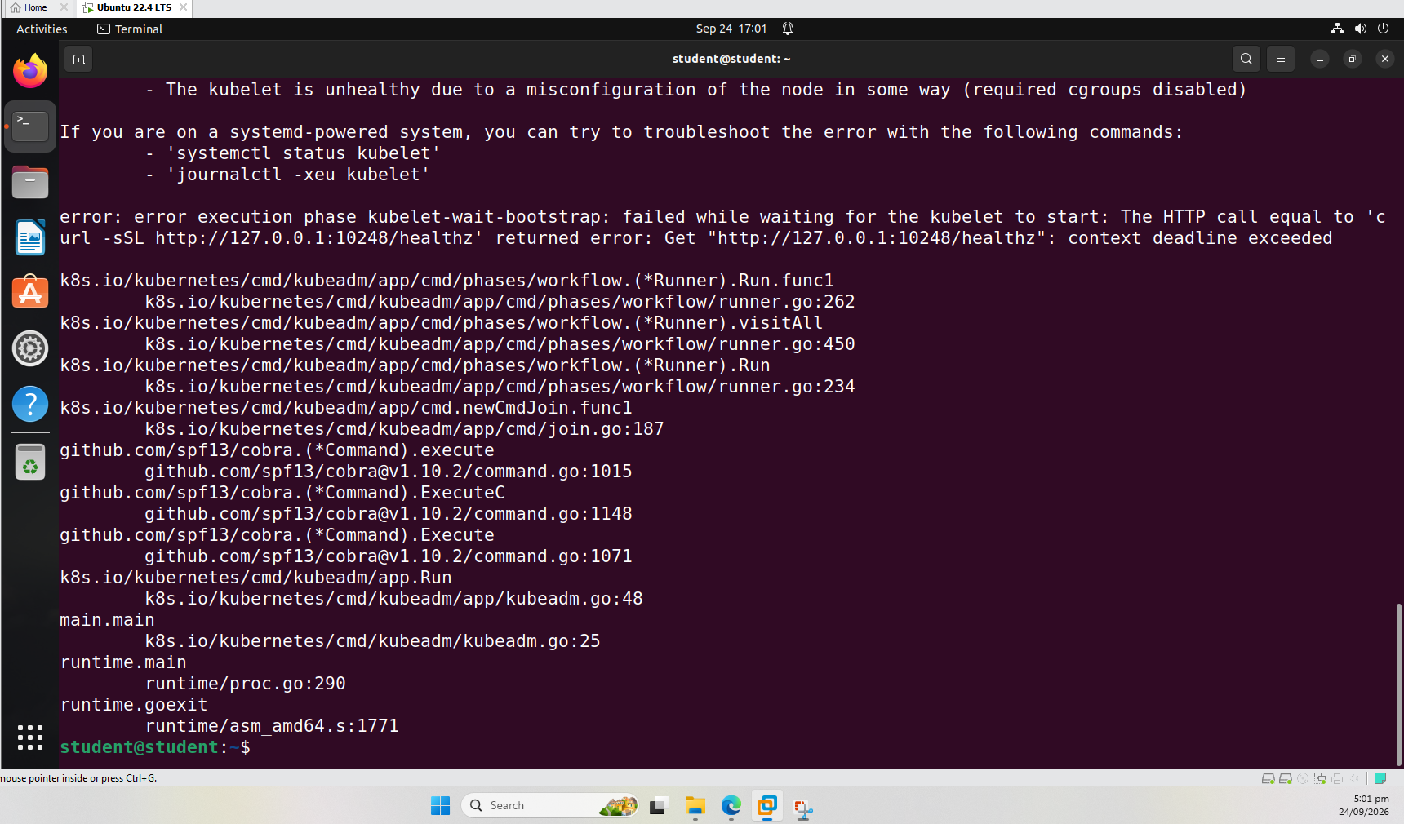
Figure 3 – kubelet error detail: cgroups misconfiguration (required cgroups disabled)
4.2 Diagnosing cgroup and resource configuration
Checked cgroup controllers, available memory, CPU cores and Docker's cgroup driver:
cat /sys/fs/cgroup/cgroup.subtree_control
cat /sys/fs/cgroup/user.slice/cgroup.subtree_control
free -h
docker info | grep -i cgroup
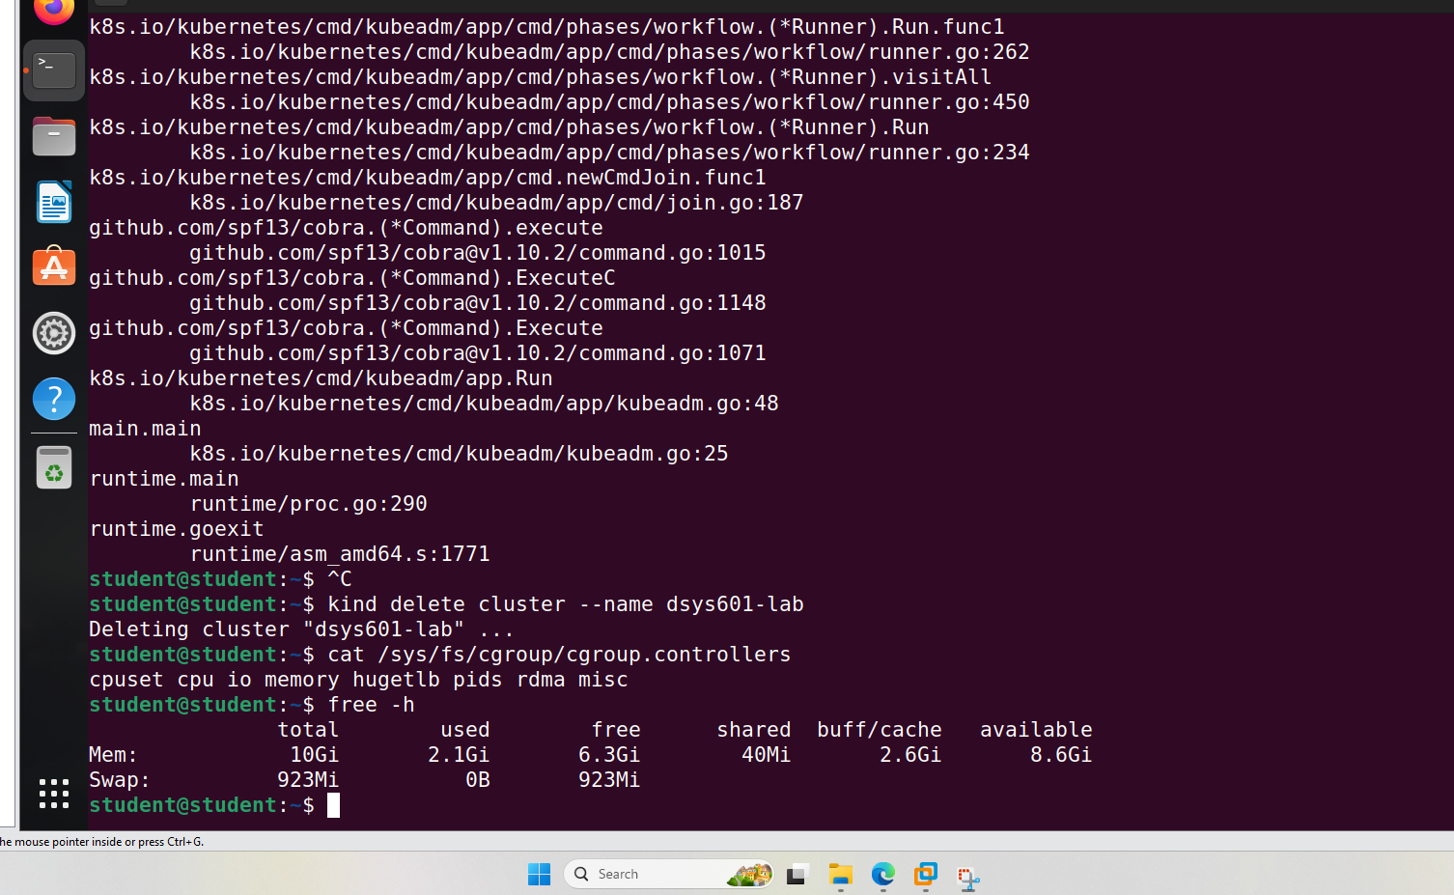
Figure 4 – cgroup controllers and memory check
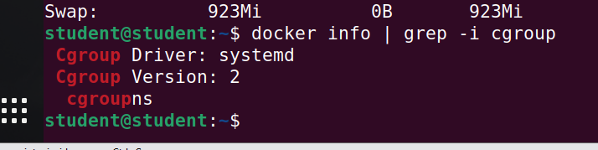
Figure 5 – Docker cgroup driver: systemd, version 2
4.3 Checking disk space
Disk space was found to be 90% full with only 1.9 GB free, a secondary contributing factor:
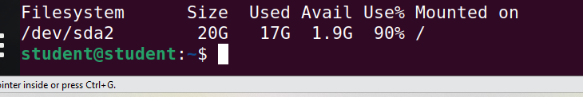
Figure 6 – Disk space at 90% usage before cleanup
docker system prune -a --volumes
df -h /
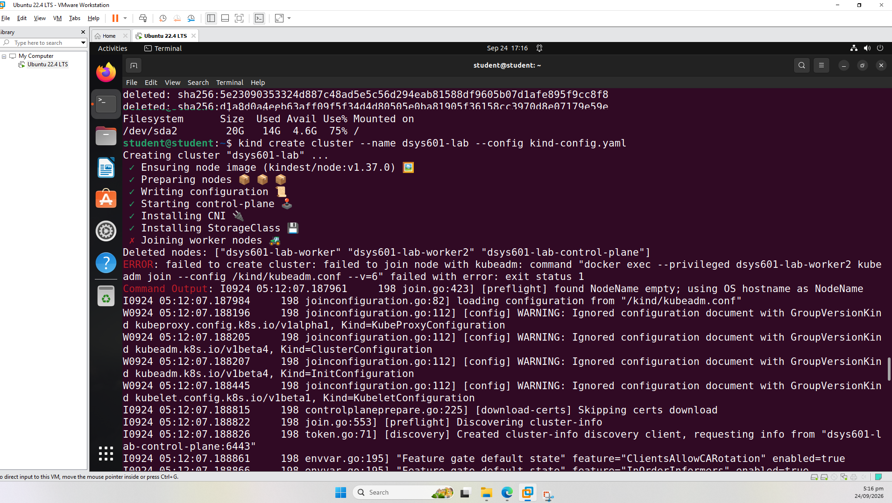
Figure 7 – Retry after freeing disk space (4.6G available) – still failed at worker join
4.4 Root cause: cgroup delegation
Further investigation showed that user.slice only delegated 'memory' and 'pids' controllers, missing 'cpu', 'cpuset' and 'io', which Kind/kubelet require. This was fixed with a systemd delegation override:
sudo mkdir -p /etc/systemd/system/user@.service.d
sudo nano /etc/systemd/system/user@.service.d/delegate.conf
[Service]
Delegate=cpu cpuset io memory pids
sudo systemctl daemon-reload
sudo reboot

5. Successful Cluster Creation
After the cgroup delegation fix and a reboot, the cluster was created successfully, including all worker nodes joining:
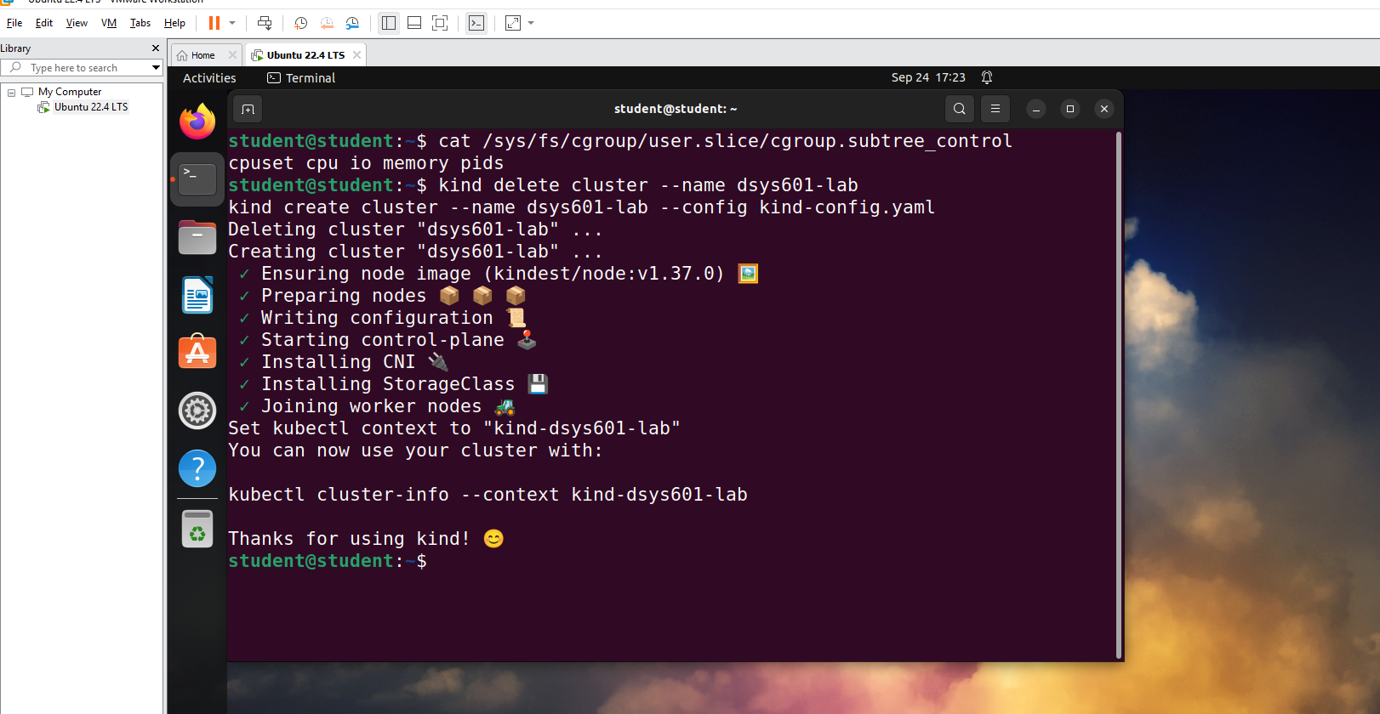
Figure 8 – kind create cluster completing successfully, all steps passed

6. Verification of the Multi-Node Cluster
The cluster was verified using kubectl, confirming one control-plane and two worker nodes, all in Ready status:
kubectl get nodes
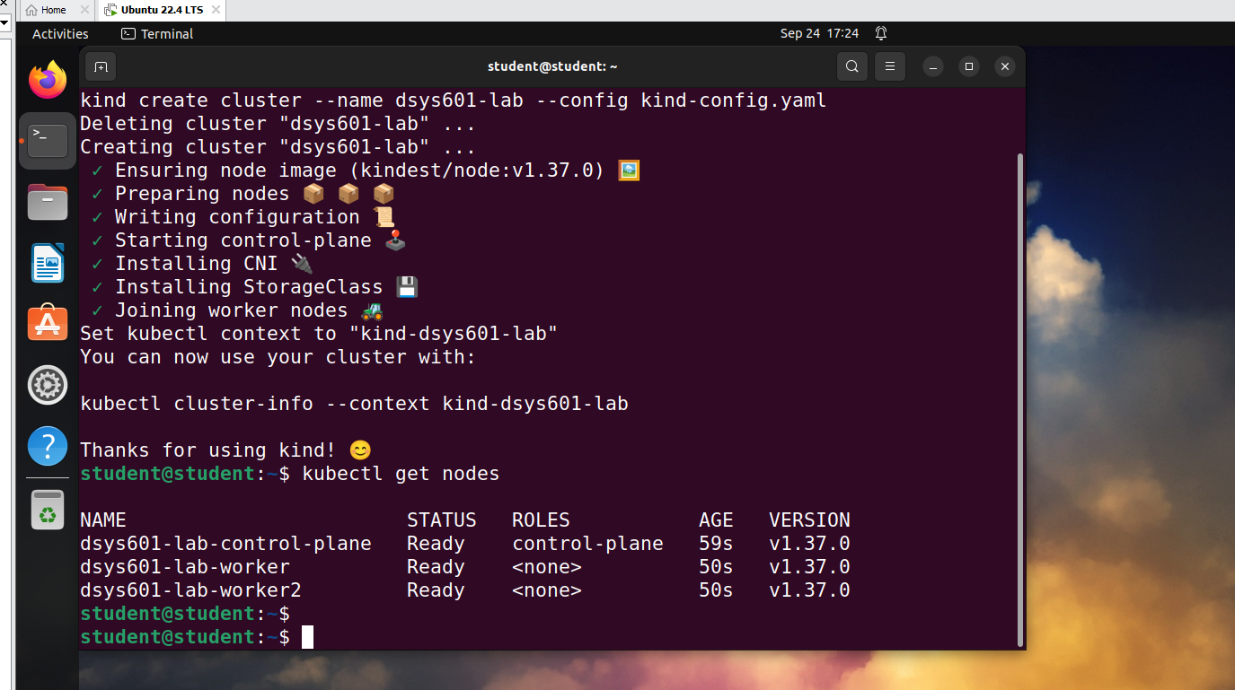
Figure 9 – kubectl get nodes showing all 3 nodes Ready

7. Reproducibility – Version Control on GitHub
To satisfy the reproducibility requirement, the cluster configuration and setup/teardown scripts were committed to a GitHub repository so the environment can be rebuilt from source.
7.1 Git installation and repository clone
sudo apt update && sudo apt install git -y
git config --global user.name "Kabir Singh Thukrai"
git config --global user.email "kabirthukral2@gmail.com"
git clone https://github.com/kat0870/dsys601-k8s-observability-lab.git
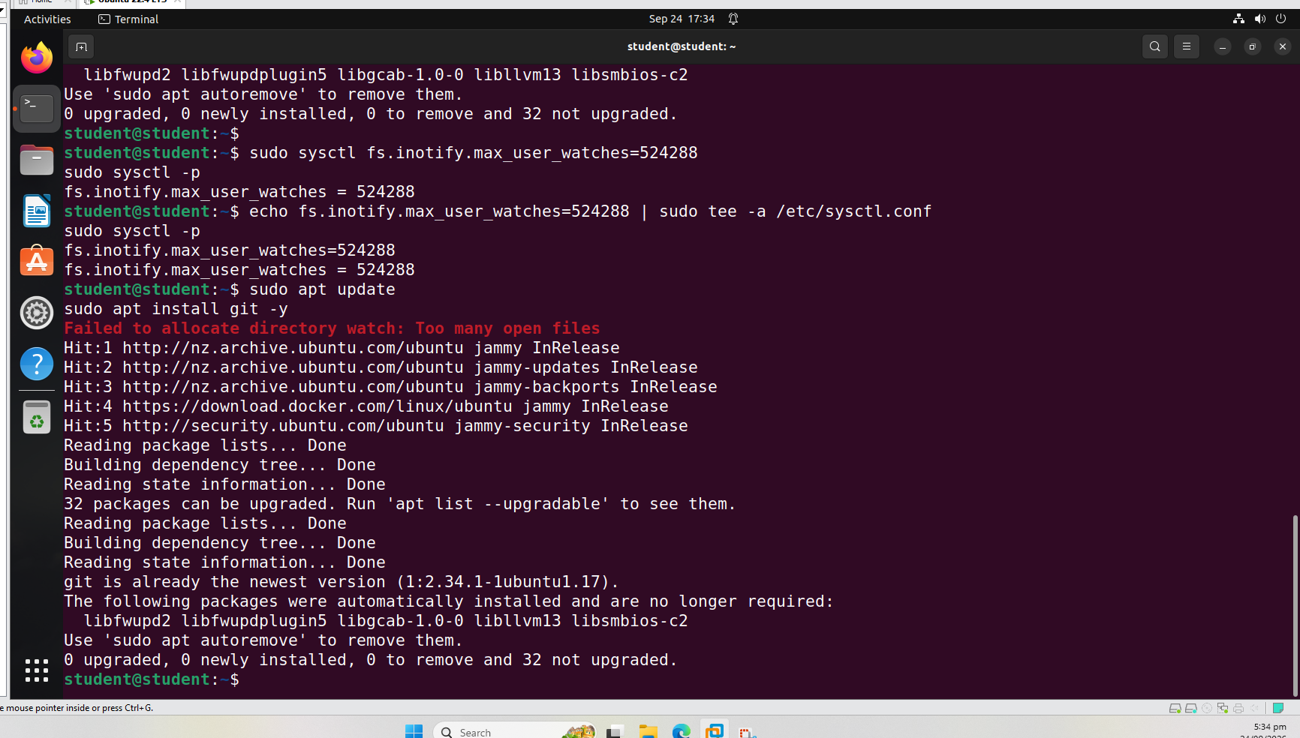
Figure 10 – Git already installed on the VM
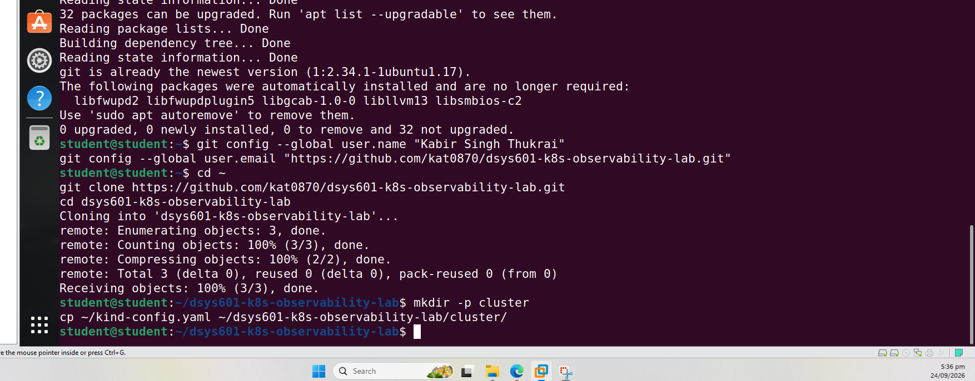
Figure 11 – Repository cloned successfully
7.2 Adding cluster config and scripts
A setup script and a teardown script were added alongside the Kind configuration file:
cluster/kind-config.yaml
cluster/setup-cluster.sh -> kind create cluster ... && kubectl cluster-info
cluster/teardown-cluster.sh -> kind delete cluster --name dsys601-lab
chmod +x cluster/setup-cluster.sh cluster/teardown-cluster.sh
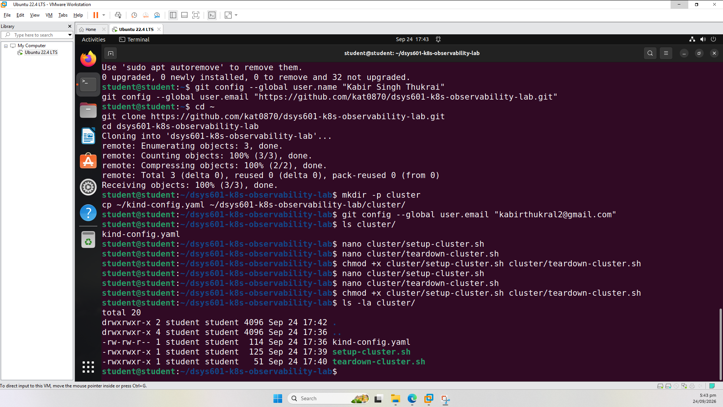
Figure 12 – Cluster files confirmed in the repo folder (config + executable scripts)
7.3 Committing and pushing to GitHub
git add .
git commit -m "Add Kind cluster config and setup/teardown scripts for multi-node lab"
git push origin main
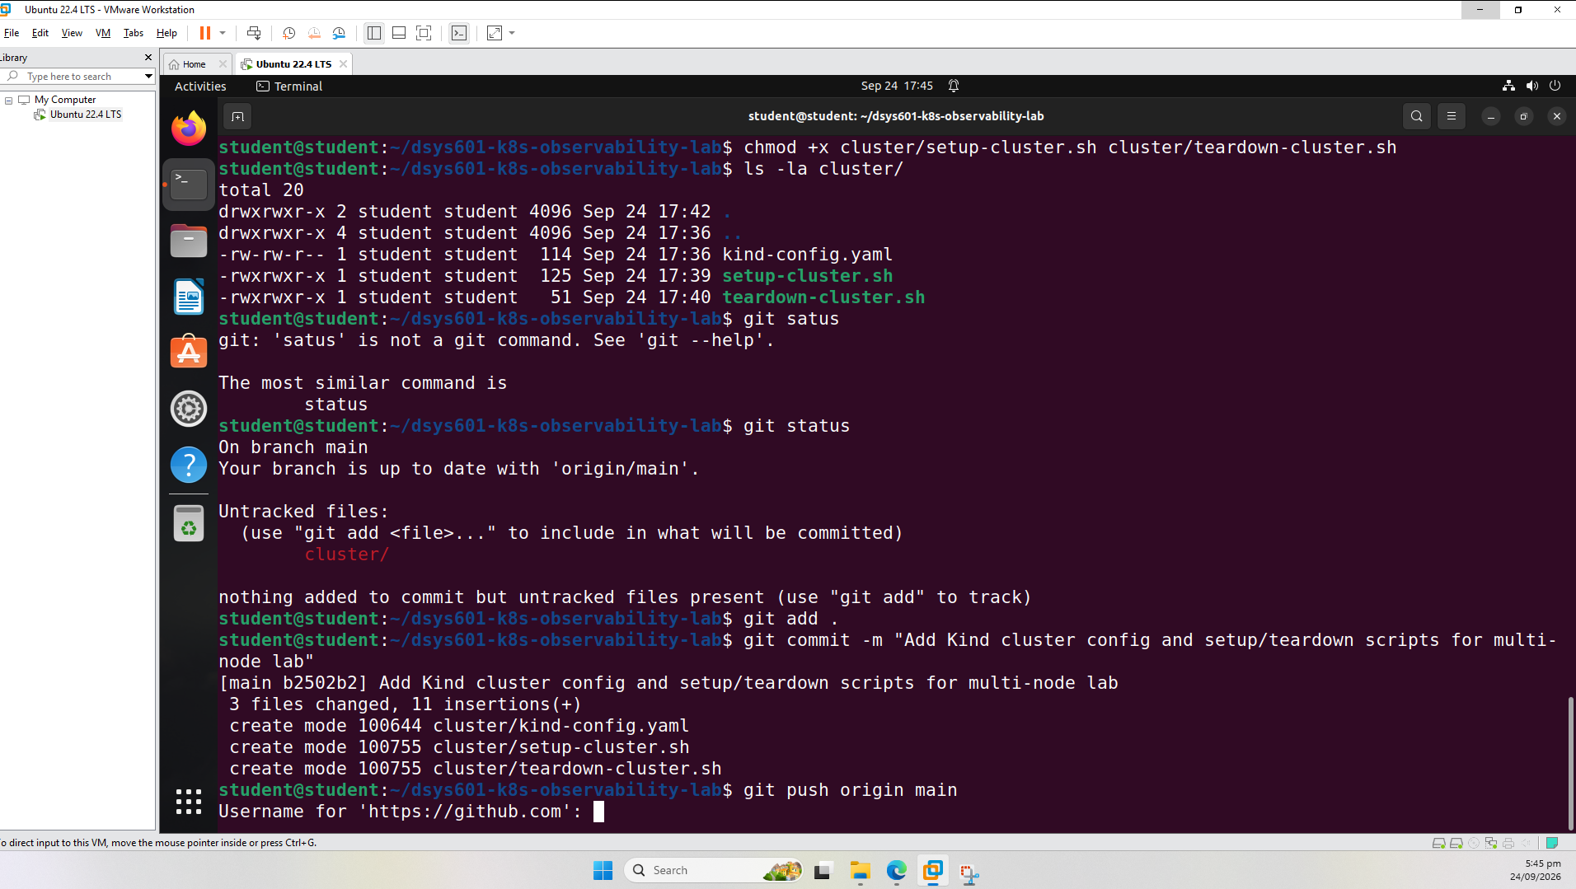
Figure 13 – Commit created (3 files changed) and push authentication prompt
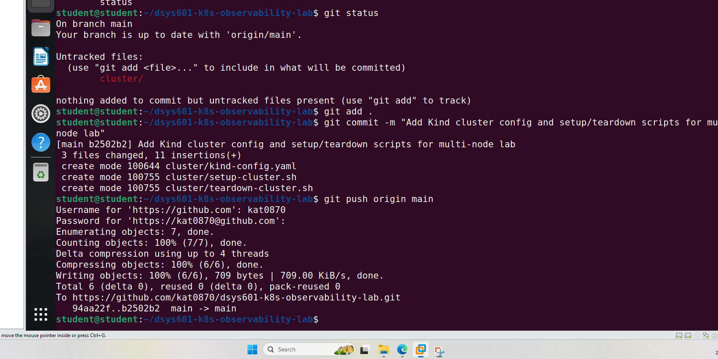
Figure 14 – Push completed successfully to GitHub (main -> main)

8. Task 4 Summary
- Reproducible Kind configuration created for 1 control-plane + 2 worker nodes.
- Cluster build initially failed due to a cgroup delegation issue in the VM; root cause diagnosed and resolved via a systemd delegation override.
- Cluster successfully rebuilt and verified – all 3 nodes reported Ready via kubectl.
- Setup and teardown scripts, plus the Kind config file, committed and pushed to GitHub for reproducibility.

Task 5 – Demo Application Deployment
Two- to Three-Service Demo Application as the Observation Target

9. Objective
Deploy a small multi-service demo application onto the multi-node Kind cluster to act as the observation target for the later Prometheus/Grafana monitoring stack. The application uses three tiers: a frontend, an API, and a datastore, each as a separate Kubernetes Deployment and Service, using lightweight public images so project time is spent on the observability layer rather than application development.

10. Application Design
The demo application consists of three services, deployed into a dedicated 'demo-app' namespace:
- Frontend – nginx (nginx:stable-alpine), exposed via a NodePort Service
- API – httpbin (kennethreitz/httpbin), a standard REST test service, 2 replicas, exposed via a ClusterIP Service
- Datastore – Redis (redis:7-alpine), exposed via a ClusterIP Service
All resources are defined in a single manifest file, app/demo-app.yaml, with CPU/memory requests and limits set on every container.
kubectl apply -f app/demo-app.yaml
namespace/demo-app created
deployment.apps/redis created
service/redis created
deployment.apps/api created
service/api created
deployment.apps/frontend created
service/frontend created

11. Deployment Verification
All pods and services were confirmed running in the demo-app namespace:
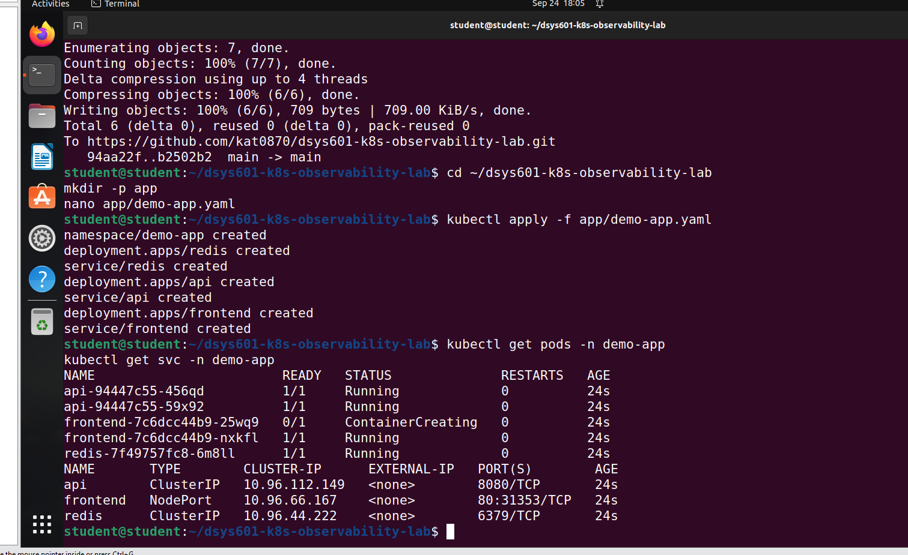
Figure 15 – kubectl apply output and kubectl get pods/svc showing all pods Running

12. Application Access Testing
Kind does not automatically expose NodePort services to the host, so kubectl port-forward was used to verify each service tier directly.
12.1 Frontend (nginx)
kubectl port-forward -n demo-app svc/frontend 8081:80
curl http://localhost:8081
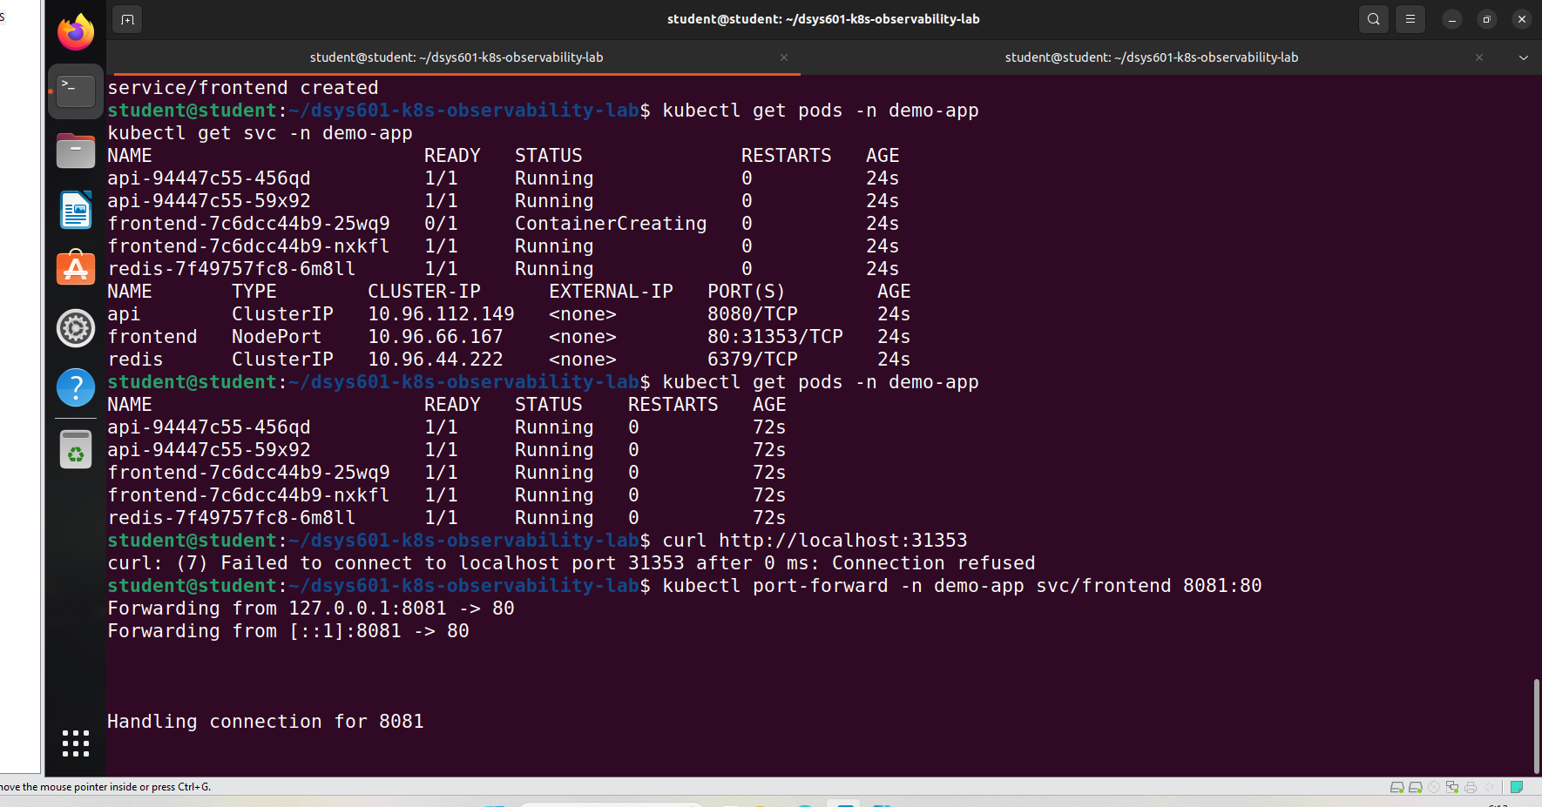
Figure 16 – Port-forward established for the frontend service (8081 -> 80)
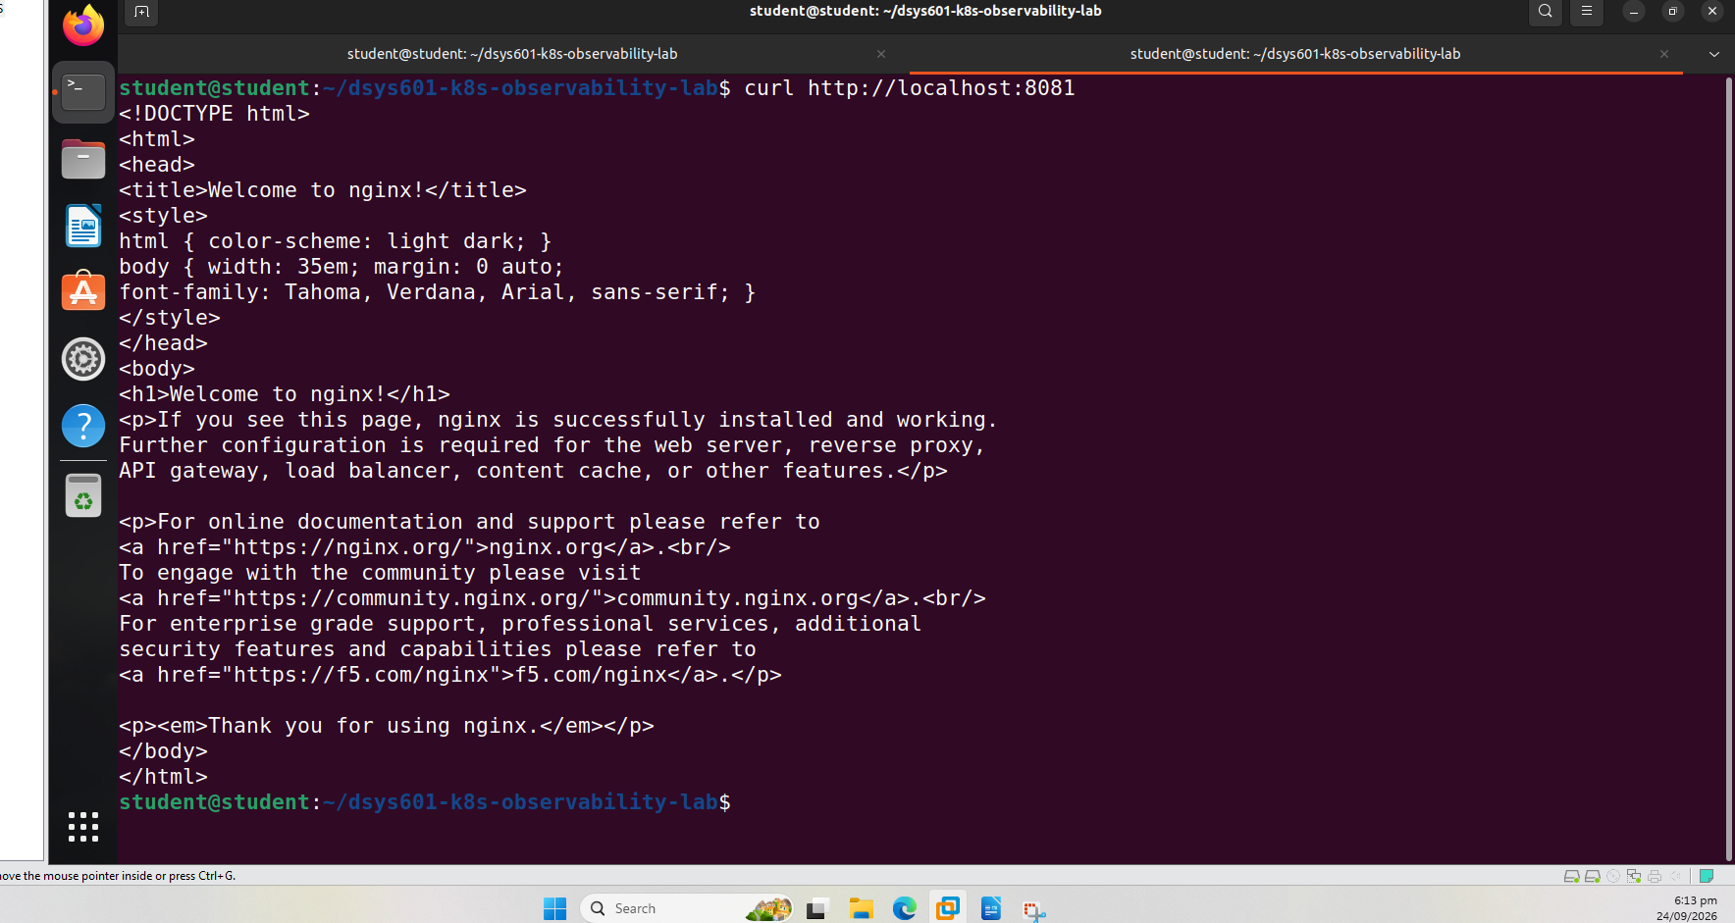
Figure 17 – curl confirms the nginx welcome page is served
12.2 API (httpbin)
kubectl port-forward -n demo-app svc/api 8082:8080
curl http://localhost:8082/get
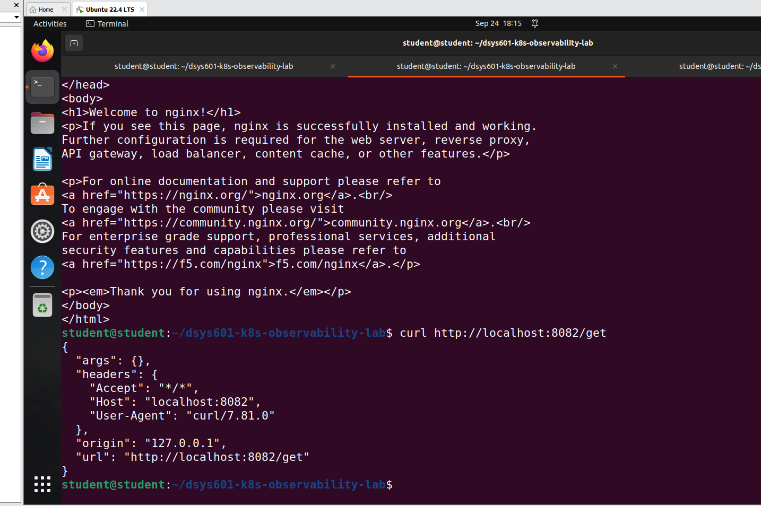
Figure 18 – curl confirms the API returns a valid JSON response
12.3 Visual confirmation in browser
The same endpoints were also verified visually using Firefox on the VM:
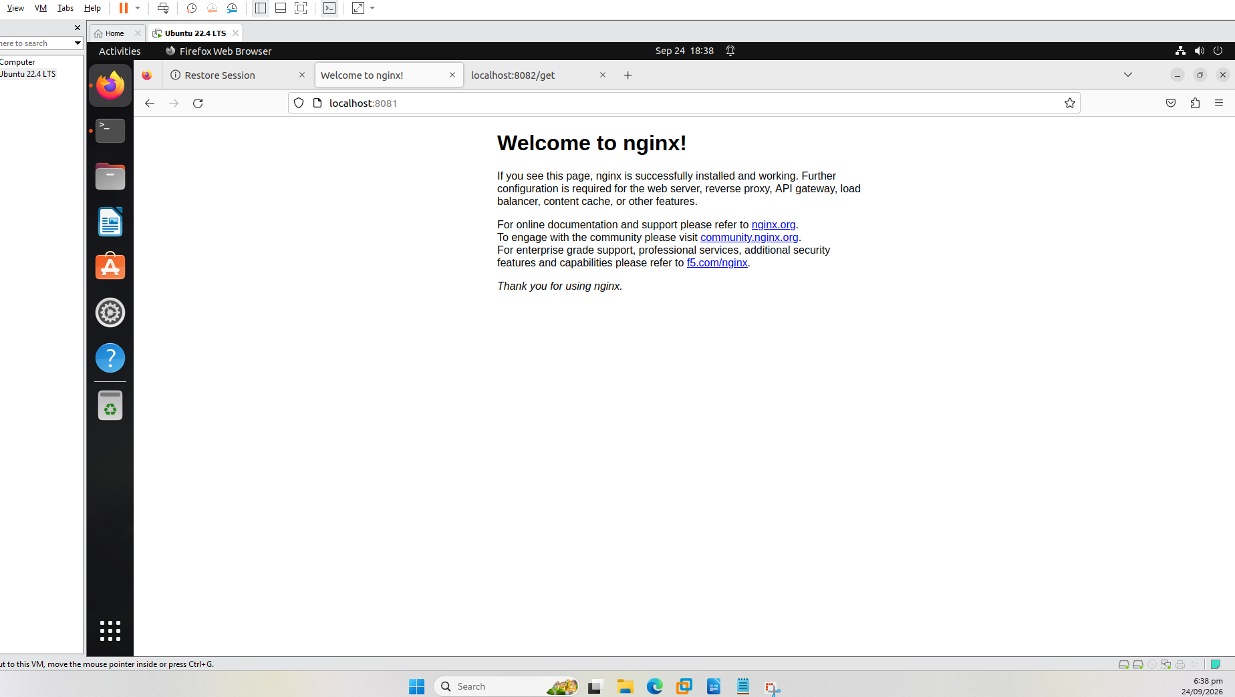
Figure 19 – Frontend rendered in Firefox at localhost:8081
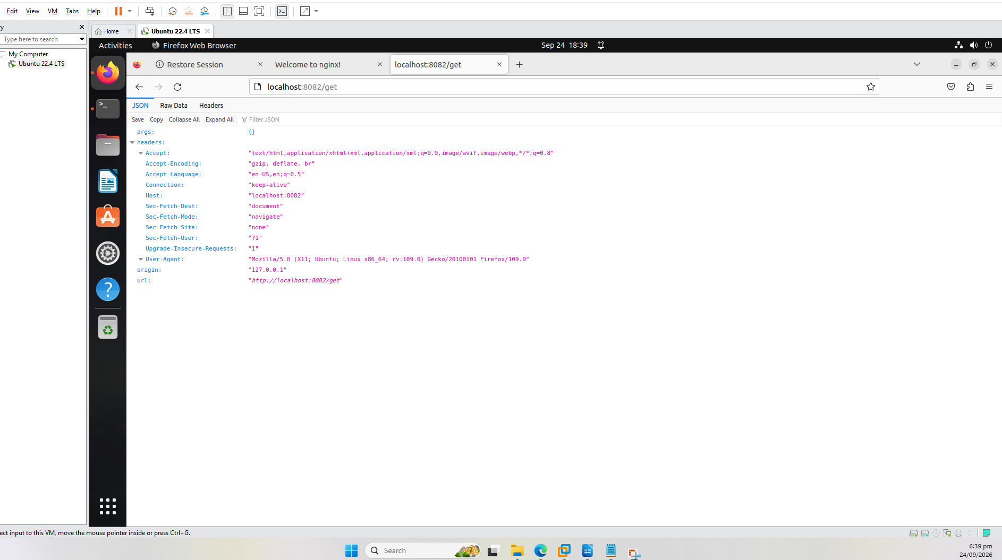
Figure 20 – API JSON response rendered in Firefox at localhost:8082/get

13. Reproducibility – Version Control on GitHub
The application manifest was committed and pushed to the same GitHub repository used for the cluster configuration, under a new 'app/' folder.
git add app/demo-app.yaml
git commit -m "Add demo application manifests (frontend, api, redis) for observability target"
git push origin main
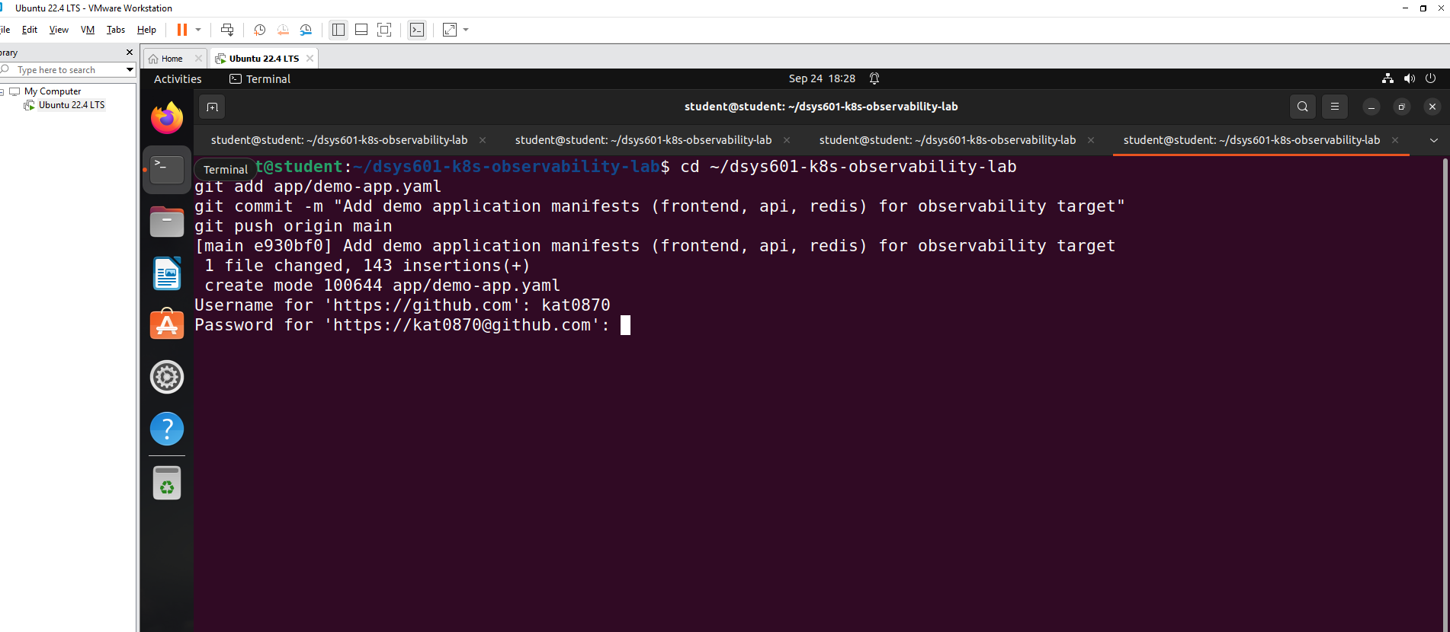
Figure 21 – Commit created (1 file changed, 143 insertions) and push authentication prompt
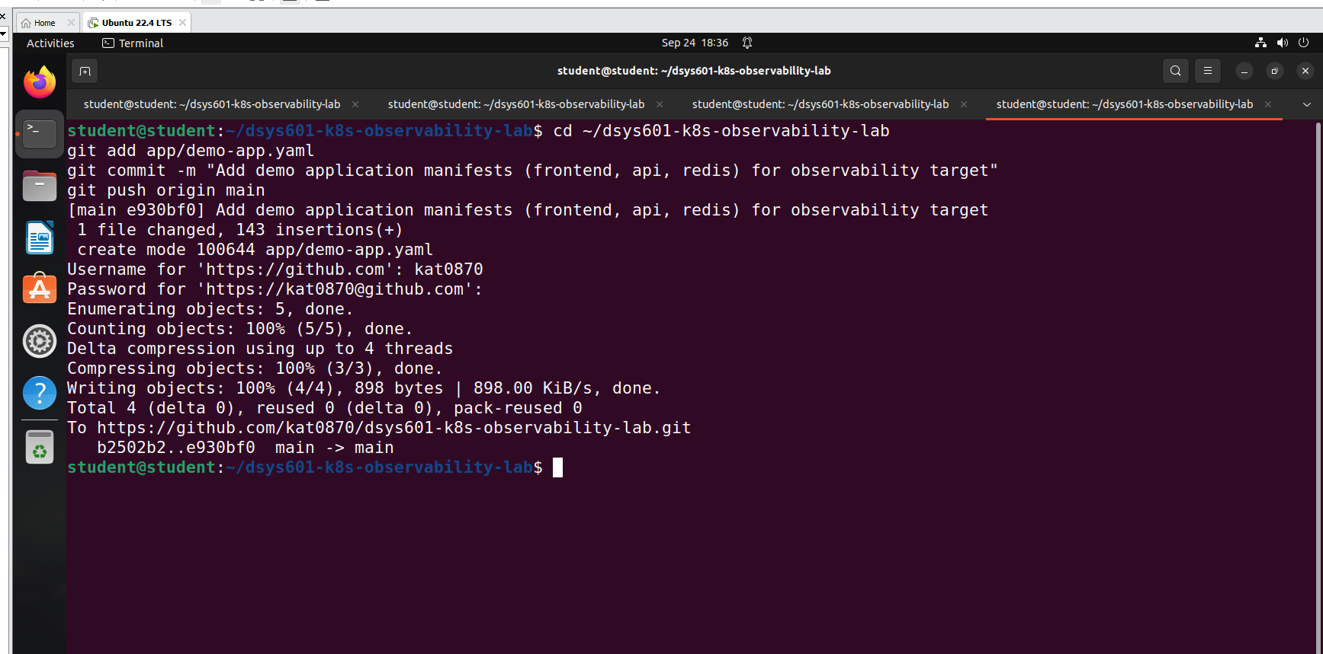
Figure 22 – Push completed successfully to GitHub (main -> main)

14. Task 5 Summary
- Three-tier demo application (frontend/nginx, API/httpbin, datastore/redis) deployed to the Kind cluster as Deployments and Services.
- All pods confirmed Running and all services verified reachable via kubectl port-forward and browser testing.
- Application manifests committed and pushed to GitHub for reproducibility, alongside the Task 4 cluster configuration.
- Repository: https://github.com/kat0870/dsys601-k8s-observability-lab

